What? Coin/Money Drive
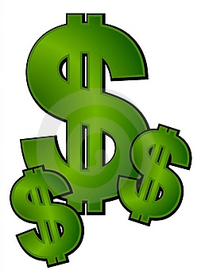
When? February 15th-19th – this is President’s Day week
Where? Lincoln Montessori
Why? To raise money to donate to Mercy Meals on February 20th
How it works…
Each class will bring in a specific coin each day – we also wanted to tie this in with the Presidents on the coins as well.
Monday – Pennies – Abraham Lincoln – 16th president
Tuesday – Nickels – Thomas Jefferson – 3rd president
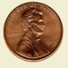
Wednesday – Dimes – Franklin D. Roosevelt - 32nd president
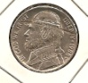
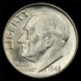
Thursday – Quarters – George Washington – 1st president
Friday – Paper money - $1 – George Washington – 1st president
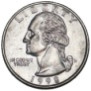
$5 – Abraham Lincoln – 16th president
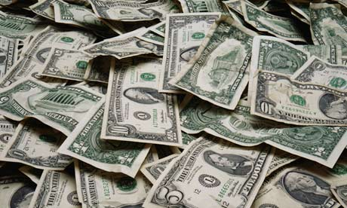
$10 – Alexander Hamilton – not a president
$20 – Andrew Jackson – 7th president
$50 – Ulysses S. Grant – 18th president
$100 – Benjamin Franklin – not a president
We will tally up each classroom’s total in the class each day.
The winning class will receive ice cream sandwiches on Monday, February 22nd.
GOOD LUCK EVERYONE!!

